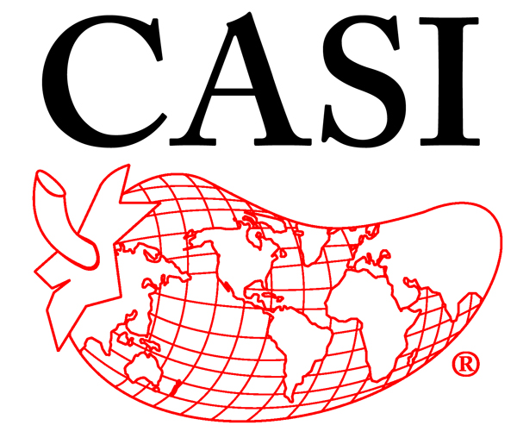
PROPOSED CHANGES
TO THE 2024 CASI OFFICIAL RULES

No. | Current Rule | Proposed Change | Rationale | Sponsoring Pod

